

**A**

**PROJECT REPORT**

**ON**

**“BAKERY MANAGEMENT SYSTEM”**

**BACHELOR OF BUSINESS ADMINISTRATION**

**(COMPUTER APPLICATION)**

**SEM IV**

**2023-2024**

**SUBMITTED TO**

**Savitribai Phule Pune University**

**DEVELOPED BY**

BUDDHIVANT TEJAS

**UNDER THE GUIDENCE OF**

**HOD: ASHA MANE**

Annasaheb Magar College Hadapsar Pune-411028.

DEPARTMENT of B.B.A.(C.A)



**CERTIFICATE**

This is certifying that Mr. Buddhivant Tejas student of Bachelors of Business Administration Computer Application has satisfactory completed the project work on “Bakery Management System” as per the syllabus laid down by the Savitribai Phule Pune University during the academic year 2023-2024

Date:-

Exam seat no Exam seat no

Project In-charge Head of Department

Internal Examiner External Examiner

**ACKNOWLEDGEMENT**

I would want to convey my heartfelt gratitude to Prof. Asha Mane, my mentor, for her invaluable advice and assistance in completing our project.

She was there to assist me every step of the way, and her motivation is what enabled us to accomplish our task effectively.

We would also like to thank all of the other supporting personnel who assisted us by supplying the equipment that was essential and vital, without which we would not have been able to perform efficiently on this project.

BUDDHIVANT TEJAS

**INDEX**

|  |  |  |
| --- | --- | --- |
| **Chapter**  **No.** | **Particular Name** | **Page No.** |
| **1.** | **Introduction:-** | 5 |
|  | 1.1 Introduction Of System | 6 |
|  | 1.2 Scope Of System | 7 |
|  | 1.3 Propose Of The System | 8 |
| **2.** | **System Analysis:-** | 9 |
|  | 2.1 Feasibility Study | 9 |
|  | 2.2 Fact Finding Technique | 10 |
|  | 2.3Hardware and software Requirement | 7 |
| **3.** | **System Design:-** | 8 |
|  | 3.1 ERD | 9 |
|  | 3.2 DFD | 10 |
|  | 3.3 File Design | 11 |
|  | 3.4 Data dictionary | 12 |
| **4** | **Forms And Report** | 13 |
| **5** | **Testing** | 14 |
| **6** | **Advantages & Limitation** | 15 |
| **7** | **Conclusion** | 16 |
| **8** | **Limitation** | 17 |
| **9** | **Future Enhancement** | 18 |
| **10** | **References** | 18 |

1. **INTRODUCTION**

In the vibrant world of bakery management, efficiency and customer satisfaction are paramount. Our Bakery Management System (BMS) project is crafted with the college environment in mind, offering a comprehensive solution to address the unique challenges faced by campus bakeries.

Traditionally, patrons of college bakeries contend with long queues and wait times, detracting from their overall dining experience. However, our BMS project aims to revolutionize this process by providing a seamless and user-friendly interface, allowing students, faculty, and staff to order their favorite baked goods with ease.

At its core, the Bakery Management System serves as a digital hub for managing various bakery operations, including inventory management, order processing, menu customization, and billing. By automating manual processes and optimizing workflows, our system enables college bakeries to operate more efficiently and effectively.

* 1. **Existing System**

The existing system is a cash and paper-based system. The payment and process take a lot of time as the customer has to pay the exact amount and wait for the change.

If the change is not available at the time, a coupon is provided which should be shown at the counter at the next purchase.

**1.2 Scope of The System**

The scope of the Bakery Management System (BMS) project encompasses a wide range of functionalities and features aimed at optimizing bakery operations. Here's an overview of the scope of the system:

* + Allow users to browse through menus, select items, and place orders.
  + Enable users to track the status of their orders in real-time.
  + Generate accurate invoices for customer orders, including itemized details and pricing.
  + Support various payment methods, including cash, card, and digital payment options.
  + Integrate with accounting systems for seamless financial management.
  + Maintain a database of customer profiles, including contact information and order history.

**1.3 Purpose of System**

This system is generally advantageous for avoiding spending time waiting in the queue by posting orders directly to the bakery without delay and also by scheduling orders ahead of time.

It saves time and also the technique dealing with is easy.

Overall, the purpose of the Bakery Management System is to optimize bakery operations, improve customer satisfaction.

**2. SYSTEM ANALYSIS**

**2.1 Feasibility study**

Define the scope and objectives of the system, such as the features, functions, requirements and specifications.Identify the hardware and software requirements for the system, such as the devices, platforms, applications, databases, etc.Assess the availability and adequacy of the technical resources and skills needed to develop and maintain the system, such as the developers, testers, administrators, etc.Evaluate the compatibility, reliability, security and maintenance of the system, such as how it will integrate with the existing systems

Feasibility study includes consideration of all the possible ways to provide a solution to the given problem the proposed solution should satisfy all the user requirement and should be flexible enough so that future changes can be easily done based on the future upcoming requirements.

1. **Economic Feasibility**

Estimate the initial and recurring costs of developing and operating the system, such as the capital expenditure, operational expenditure, maintenance expenditure, etc.Forecast the expected revenues and savings from using the system, such as the income generation, cost reduction, efficiency improvement, etc.Analyze the non-monetary benefits and costs of using the system, such as the customer satisfaction, employee engagement, social impact, environmental impact, etc.Calculate the return on investment (ROI), break-even point (BEP) and payback period (PP) of the system, such as how much profit or loss it will generate over a period of time, how long it will take to recover the investment in the system.

1. **Technical Feasibility**

This included the study of function, performance and constraints that may affect the ability to achieve an acceptable system. For this feasibility study, we studied complete functionality

To be provided in the system, as described in the system requirement specification (SRS) and checked if everything was possible using different type of frontend and backend platforms.

* Technical feasibility refers to the technical resources needed to develop purchase, install or operate the system
* Technical skills and capabilities of the software development.

1. **Operational Feasibility**

No doubt the proposed system is fully GUI based that is very user friendly and all inputs to be taken all self-explanatory even to a type of operational feasibility. The required software performs a series of steps to solve the system problems and user requirement.

* Operational feasibility also perform different tasks
* Solution suggestion by the team.
* A proposed system will be used effectively after it has been developed.

**2.2 Fact Finding Technique**

A database developer commonly uses several fact-finding techniques during a single database project. There are five widely used fact-finding techniques:

Various fact finding techniques were used to collect detailed information about each and every aspect of the BAKERY MANAGEMENT SYSTEM following fact finding techniques were adopted.

⦁ Fact finding technique is the formal process of using research, interviews, questionnaires, and preferences.

**OBSERVATION**

The first hand information about various activities that are carried out can be studied through observation of general procedures. The information about company is stores in database. As analyst this technique showed us many missed facts. We also found some new ways to improve existing manual procedure.

⦁ Focus groups :

Focus groups can be used to gather feedback from a group of stakeholders in a structured setting. Focus groups can be conducted in-person or online and can be used to gather feedback on online Bakery experience.

**STUDY OF DOCUMENTS**

**(RECORD REVIEW)**

A study of records maintained gave a clear idea as to how the actual process is carried out various documents which are handled their usage, formats were studied.

**INTERVIEW**

Timely discussions with concerned person were made to understand the exact requirement of the system. These discussions were also useful in bringing up new ideas as to make system more effective.

This technique is used to collect information from individuals or from groups. Through such invaluable techniques, it is possible to find much of the quality information and also some option and underlying problems.

**Questionnaire**

[Question for admin and customer]

1. **Overall Experience**
   * On a scale of 1 to 5, how would you rate your overall experience with our online cake bakery system?
   * What aspects of your experience were most satisfying?
2. **Ordering Process**
   * How easy was it to navigate through our website/app and place your order?
   * Did you encounter any difficulties during the ordering process? If so, please specify.
3. **Product Quality**
   * Were you satisfied with the quality of the cake/desserts you received?
   * Did the products meet your expectations in terms of taste, freshness, and presentation?
4. **Delivery Experience**
   * How satisfied were you with the timeliness and accuracy of the delivery?
   * Were the products delivered in good condition?

**2.3 HARDWARE AND SOFTWARE**

**REQUIREMENT**

**HARDWARE REQUIREMENT:-**

Ram : 4GB Ram for server

Storage Device : Hard Disk - 2.1 GB

Processor : Intel i5 10th generation

**SOFTWARE REQUIREMENT:-**

Operating System : Microsoft windows 11

Front End : PHP, CSS, HTML.

Back End :-MY SQL

**2.4 SYSTEM DESIGN**

**3.1 ERD-Entity Relationship Digram**

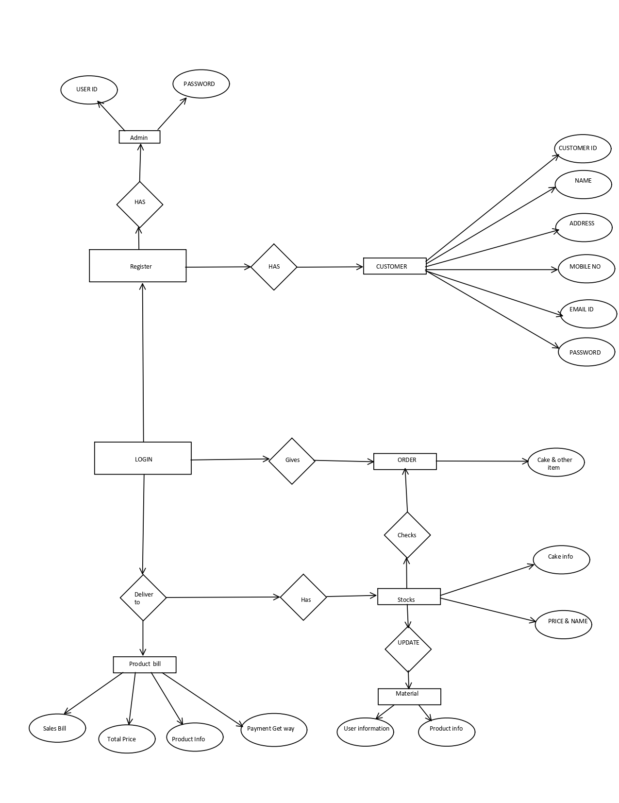

**3.2 CONTEXT LEVEL DFD:-**

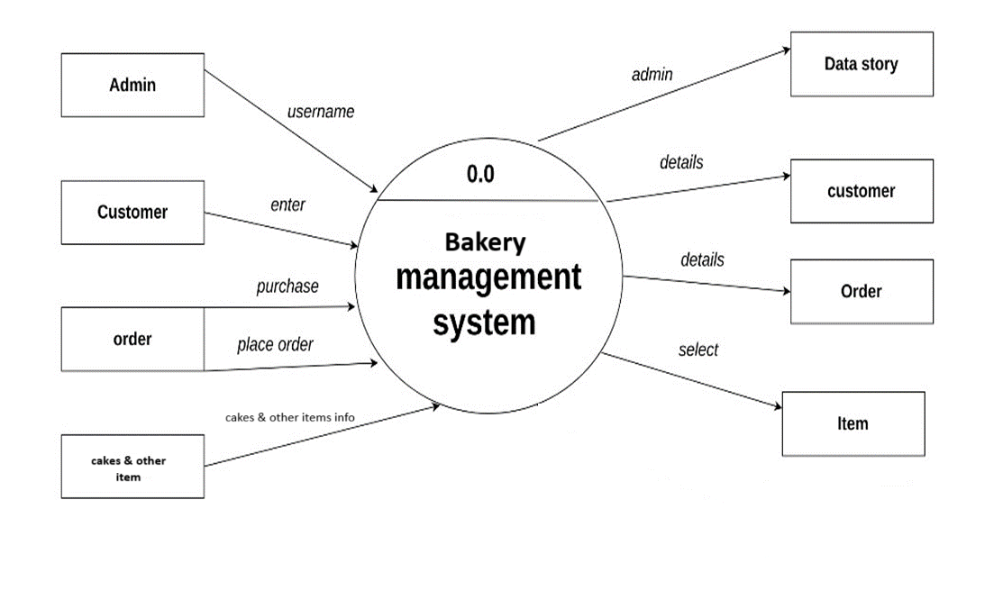

**3.3 FIRST LEVEL DFD**

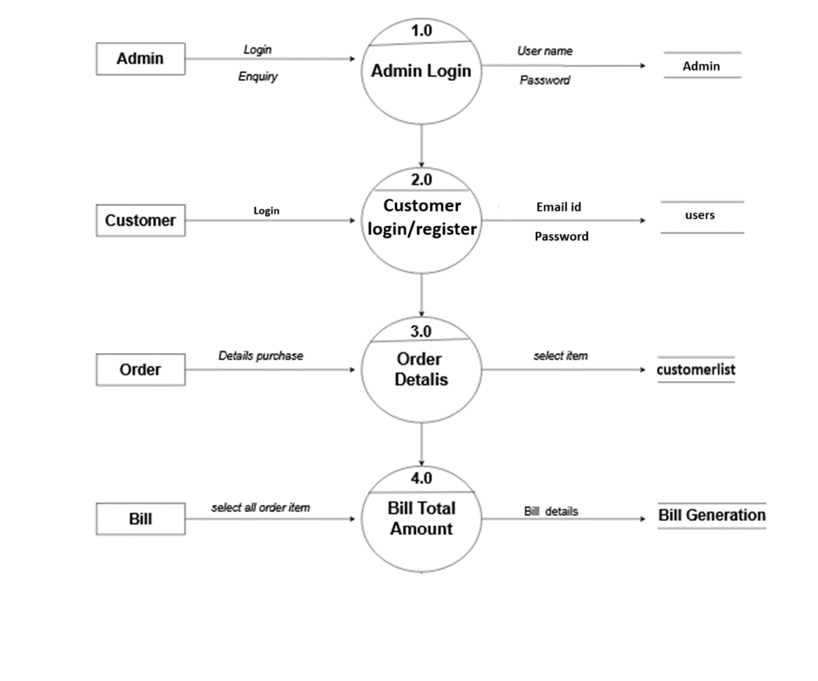

**3.4 FILE DESIGN:**

**Table admin: -**

|  |  |  |
| --- | --- | --- |
| **Field Name** | **Data Type** | **Constraints** |
| **Id** | **int(11)** | **Primary key** |
| **name** | **text** | **-** |
| **email** | **text** | **-** |
| **password** | **text** | **-** |
| **date** | **date** | **Current_timestamp** |

**Table chefsinfo: -**

|  |  |  |
| --- | --- | --- |
| **Field Name** | **Data Type** | **Constraints** |
| **csrno** | **Int (11)** | **Primary key** |
| **chefsname** | **text** |  |
| **country** | **text** |  |
| **Mobile_no** | **Int (10)** | **-** |
| **speciality** | **text** | **-** |

**Table customerlist -**

|  |  |  |
| --- | --- | --- |
| **Field Name** | **Data Type** | **Constraints** |
| **Srno** | **Int(200)** | **Primary key** |
| **Id** | **Int** | **-** |
| **Name_of_customer** | **text** | **-** |
| **email** | **text** | **-** |
| **Cake_name** | **text** | **-** |
| **mobno** | **text** | **-** |
| **address** | **text** | **-** |
| **date** | **date** | **Current_timestamp** |

**Table user:-**

|  |  |  |
| --- | --- | --- |
| **Field Name** | **Data Type** | **Constraints** |
| **Srno** | **Int(200)** | **Primary key** |
| **Name** | **Text** | **-** |
| **Email** | **Text** | **-** |
| **Mobileno** | **Int(10)** | **-** |
| **Address** | **Text** | **-** |
| **Username** | **Text** | **-** |
| **Passward** | **text** | **-** |
| **Date** | **Date** | **ctimestamp** |

**3.5 DATA DICTONARY:-**

|  |  |  |  |
| --- | --- | --- | --- |
| **Field** | **Data type**  **And**  **Data size** | **Constraints** | **Table**  **name** |
| **Id** | **Integer** | **Primary key** | **admin** |
| **name** | **text** | **-** |  |
| **email** | **text** | **-** |  |
| **password** | **text** | **-** |  |
| **date** | **Date** | **ctimestamp** |  |
|  |  |  |  |
| **csrno** | **Integer** | **Primary**  **key** | **chefsinfo** |
| **chefsname** | **Text** | **-** |  |
| **Country** | **Text** | **-** |  |
| **Mobile_no** | **Integer** | **-** |  |
| **Speciality** | **Text** | **-** |  |
|  |  |  |  |
|  |  |  |  |
| **Field** | **Data type**  **And**  **Data size** | **Constraints** | **Table**  **name** |
|  |  |  |  |
| **Srno** | **Integer** | **Primary key** | **customerlist** |
| **Id** | **Integer** | **-** |  |
| **Name_of_customer** | **Text** | **-** |  |
| **email** | **Text** | **-** |  |
| **Cake_name** | **Text** | **-** |  |
| **mobno** | **Integer** | **-** |  |
| **address** | **Text** | **-** |  |
| **date** | **date** | **ctimestamp** |  |
|  |  |  |  |
| **Srno** | **Integer** | **Primary key** | **user** |
| **Name** | **Text** | **-** |  |
| **Email** | **Text** | **-** |  |
| **Mobileno** | **int** | **-** |  |
| **Address** | **Text** | **-** |  |
| **Username** | **Text** | **-** |  |
| **Passward** | **Text** | **-** |  |
| **Date** | **Date** | **ctimestamp** |  |

**4. INPUT FORM**

Home page

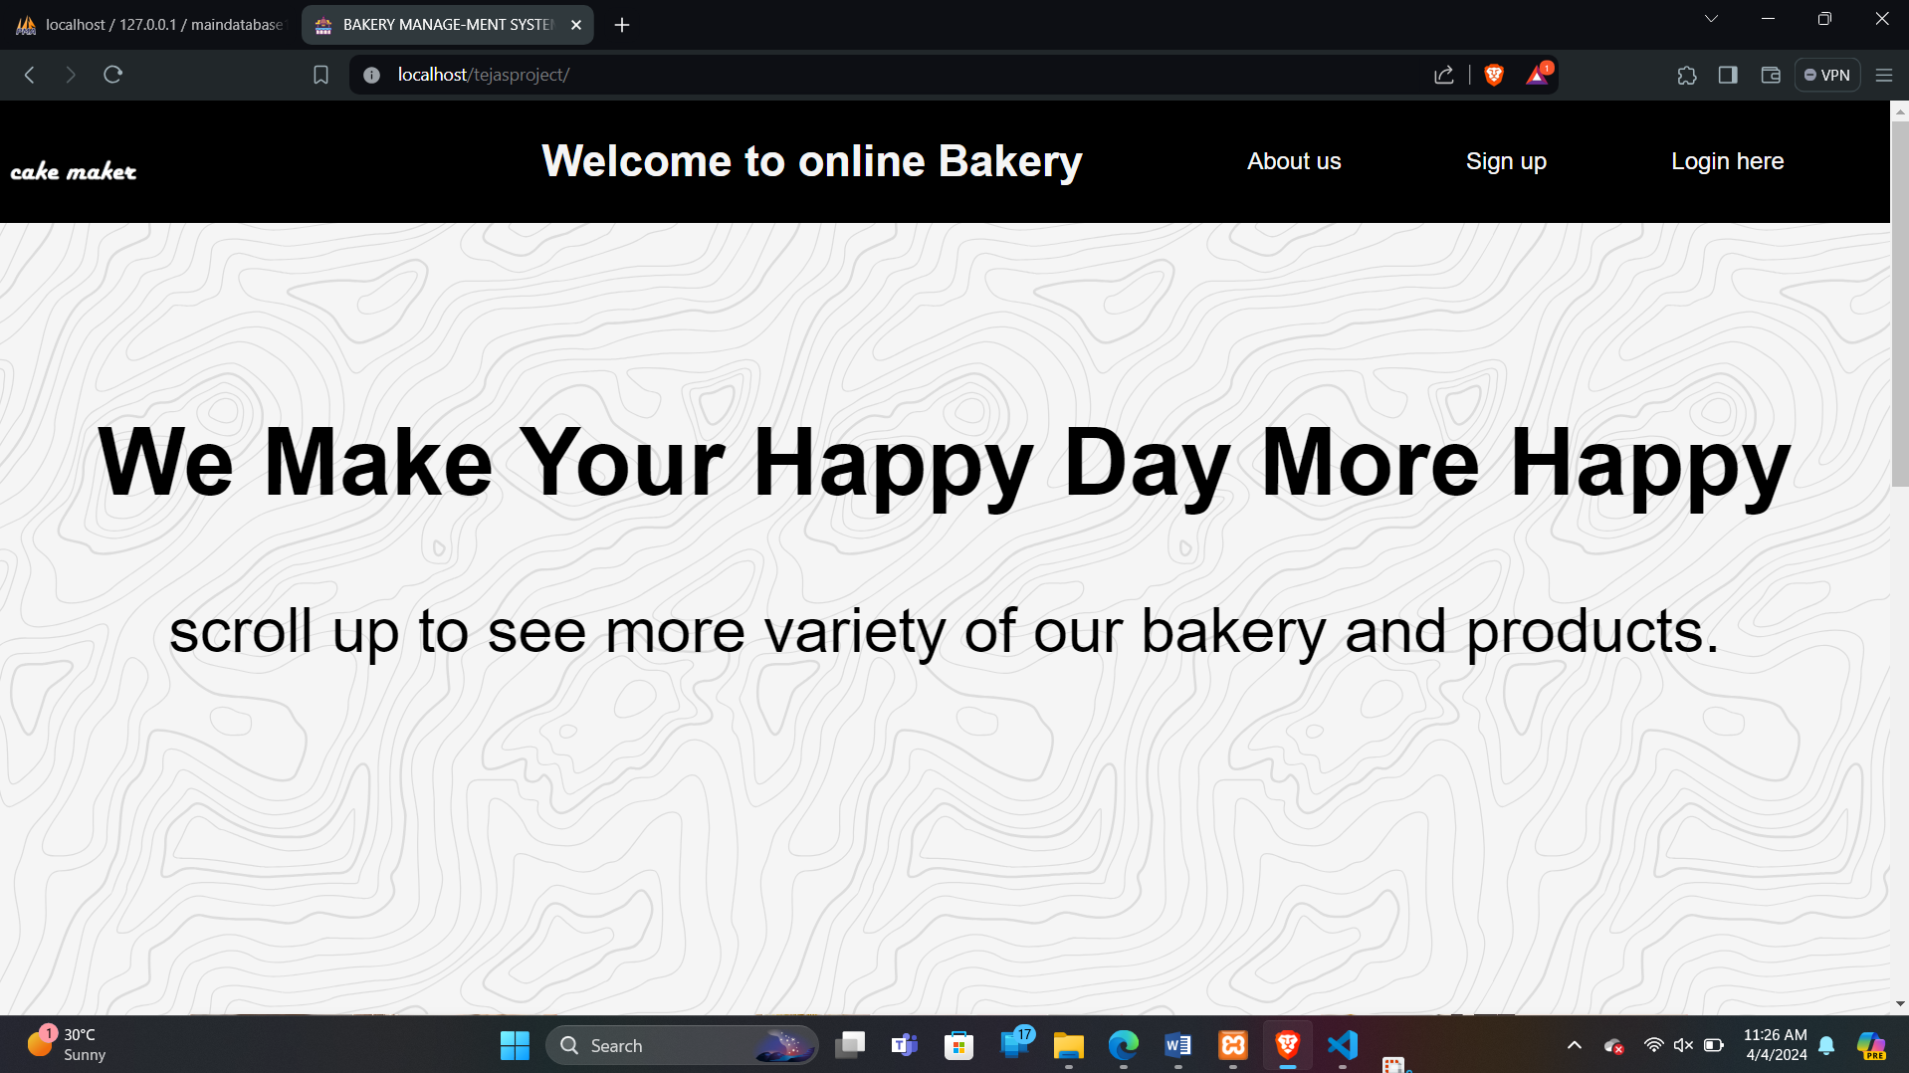

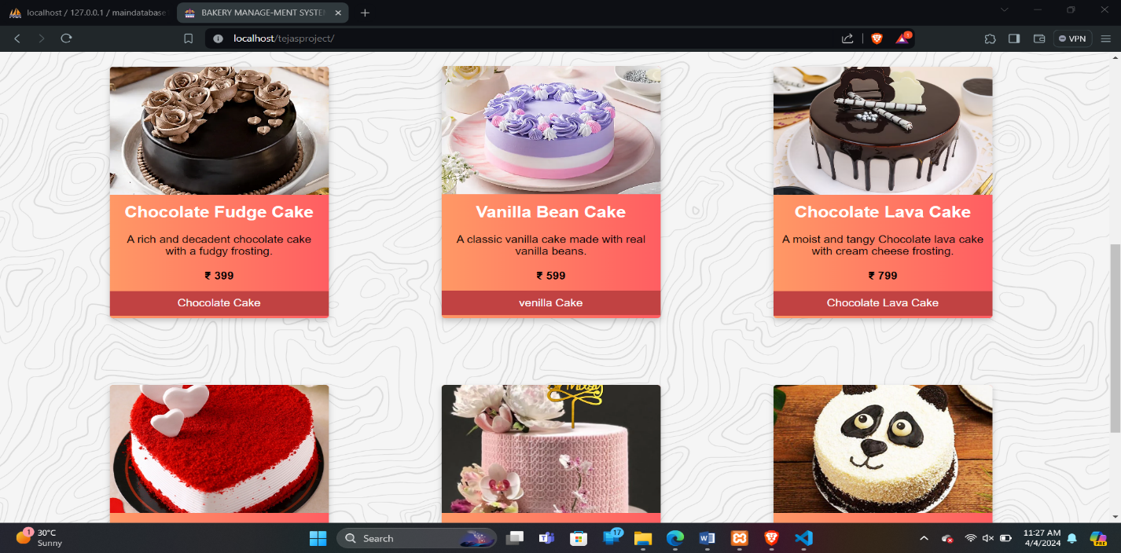

**Admin from**

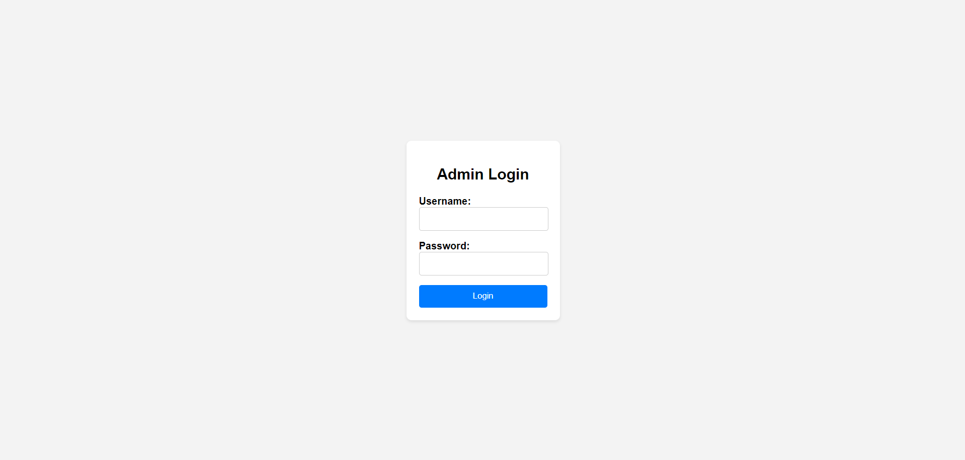

**Admin manage page**

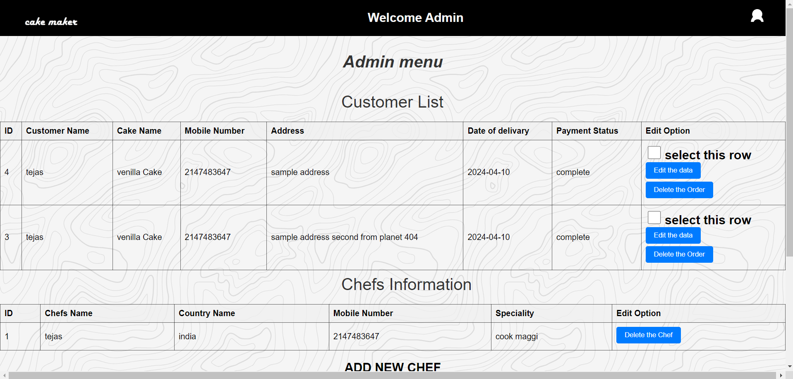

**Category**

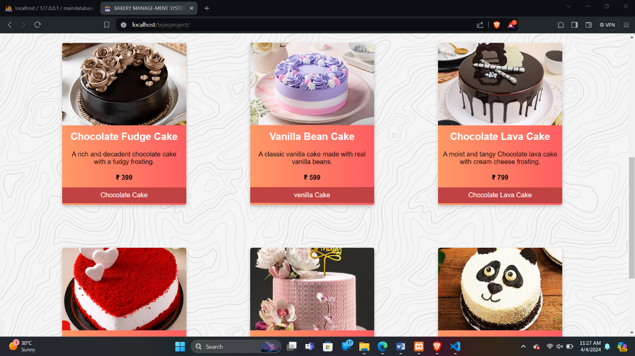

**Order details:**

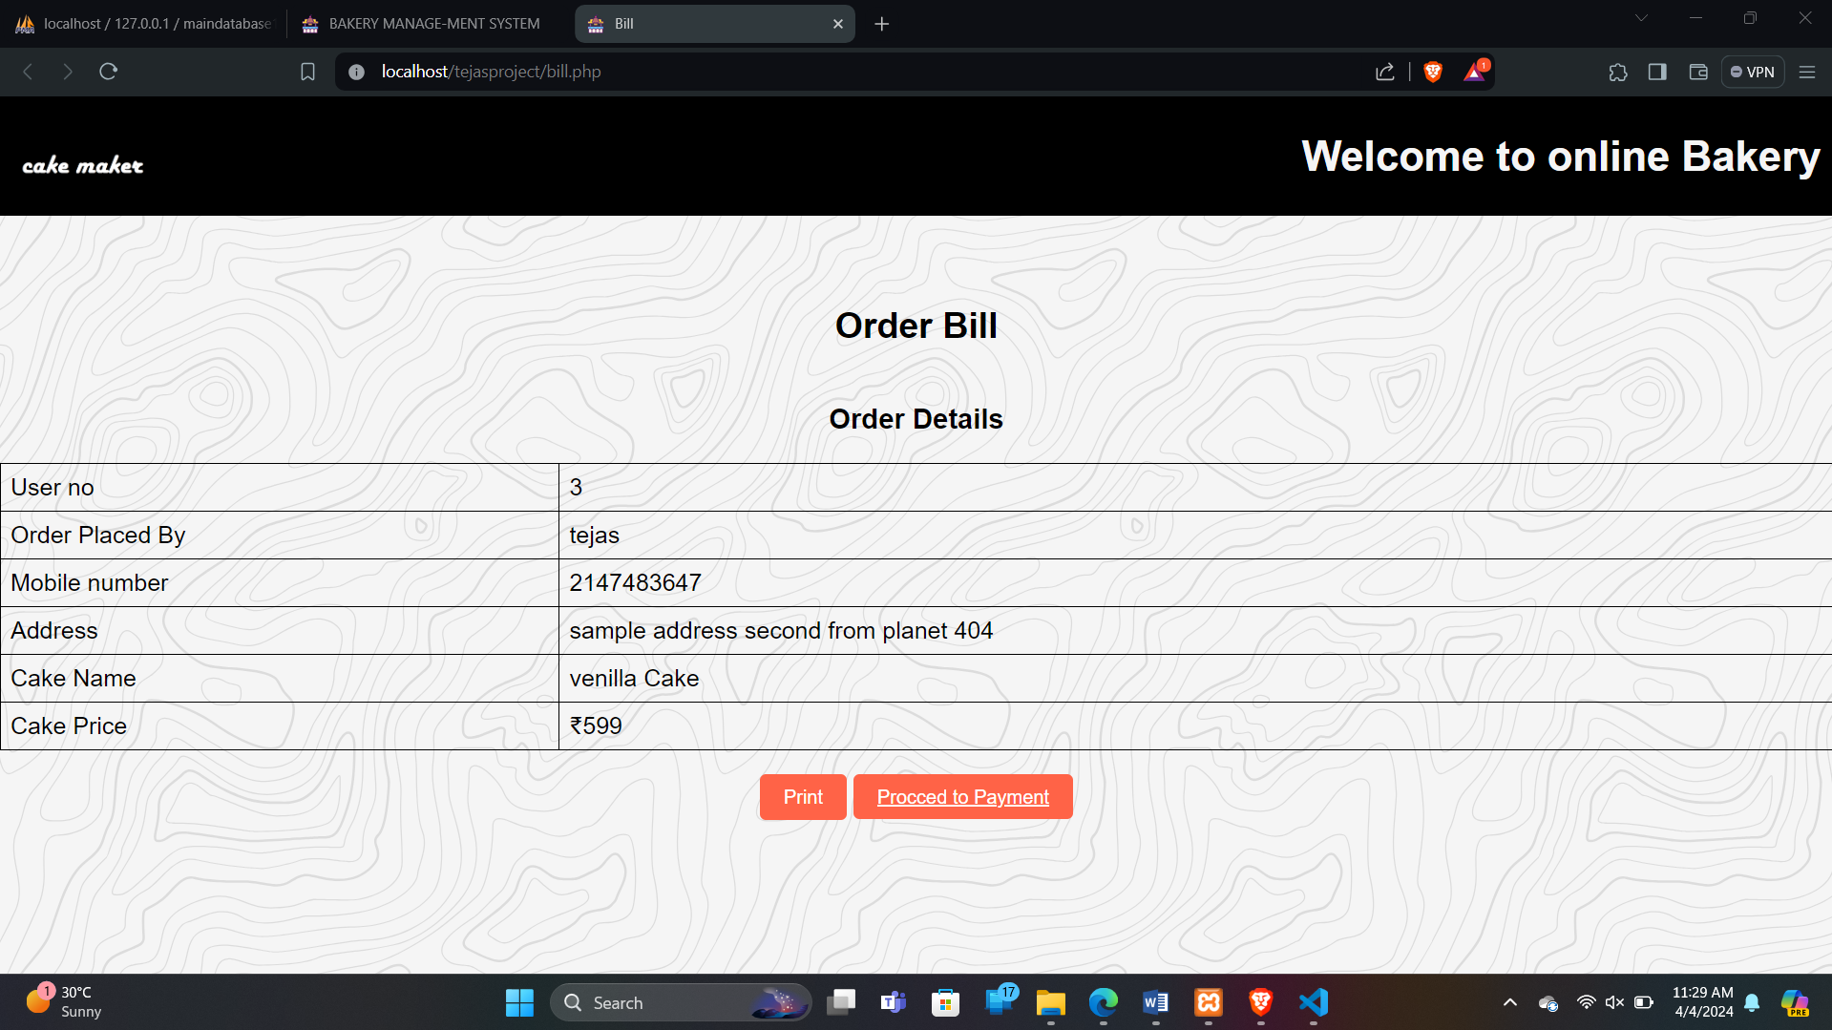

**Payment Getway:**

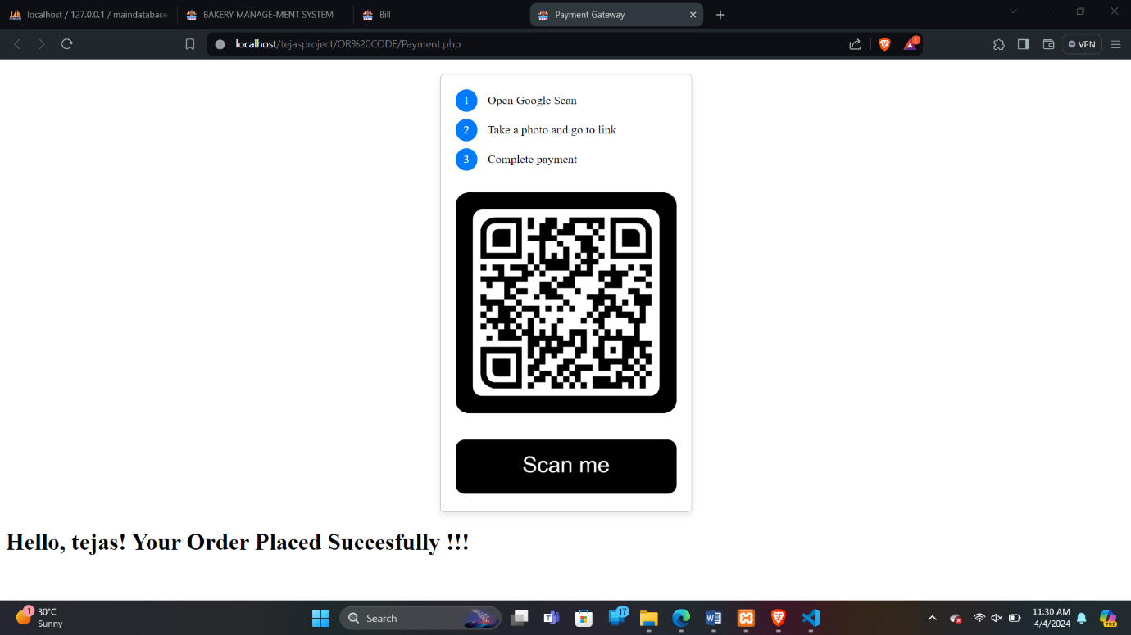

**5 TESTING:-**

Software testing is a critical element of the software quality and represents the ultimate review of specification, design and coding, “testing is the process of executing a program with the intent of coding errors”.

**OBJECTIVES:-**

The objective of testing are as follows:

* To design different tests that uncovers the errors with minimum time and cost.
* To check the software functions appear to be working according to specifications given by user.
* A successful test is one that uncovers with existing system.
* The software delivered interfaces correctly with the existing system.

**BLACK BOX TESTING**

* The end user has concluded black box testing. The user is most concerned with the inputs that the system accepted and the output that if generated.
* Using this approach, it is useful in finding the incorrect or missing function. Interface errors, errors in database, initialization and termination errors. The user has checked every GUI and reports for the error.

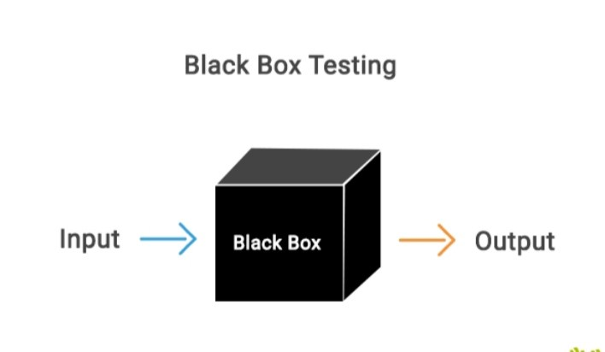

**6.Advantages & Disadvantages Advantages :-**

* · High Security and Reliability.
* · Less Man-work
* · Portable Mobile Access with Easy Accessibility
* · Save Time while generating receipts
* The transactions are executed in off-line mode, hence data for Bakery, sales capture and modification is not possible.

**Disadvantages :-**

* Risk of data leaks (in case of free or unreliable applications)
* Complicated applications are hard to understand
* Bugs can effect performance of application
* No access in absence of network

**7.LIMITATION:-**

* **Internet Dependency:** Online BMS requires a stable internet connection to function effectively. If the internet connection is slow or unstable.
* **Security Concerns:** Online BMS involves the storage and transmission of sensitive customer data, including personal information and payment details.
* **Technical Issues:** Online BMS may encounter technical issues such as server downtime, software bugs, and compatibility issues with different devices and browsers.
* **Cost of Implementation:** Implementing and maintaining an online BMS involves upfront costs for software development, infrastructure setup, and ongoing maintenance.
* **Accessibility Challenges:** Online BMS may pose accessibility challenges for users with limited internet access or technological proficiency.

**8.CONCLUSION:-**

* The development of Bakery management system involved many phases. The approach used is a top- down one concentrating on what first then how and moving to successive levels of details.
* The first phase started with a detailed study of the problems and prospects of ordering in cakes.
* This software is efficient in maintaining customer’s details and can easily perform operations on platform.

**9.FETURE ENHANCEMENTS**

1. In the future we will create more reliable long databases for fetching records. We will also try to provide best services and also online payment methods.
2. In future we will try to updated customer profile and also admin profile. Some more interesting features will be added so that customer will find it as more useful.

**10.REFERENCES**

1. [**WWW.youtube.COM**](http://WWW.youtube.COM)
2. [**WWW.javatpoint.COM**](http://WWW.javatpoint.COM)
3. [**www.google.co.in**](http://www.google.co.in)
4. [**WWW.geaksforgeeks.COM**](http://WWW.geaksforgeeks.COM)
5. [**https://www.w3schools.org/**](https://www.w3schools.org/)